**Test case 1:**

exec { 'apt-update':

command => '/usr/bin/apt-get update'

}

package { 'python':

require => Exec['apt-update'],

ensure => installed,

}

**Test case 2:**

class python{

package { 'python':

ensure => installed,

}

}

node 'puppet-agent2-bionic.local' {

include python

}

**Test case 3**:

* Check os
* run

class test1{

exec { 'test':

path => 'C:/Windows/System32/WindowsPowerShell/v1.0',

command => 'powershell -executionpolicy remotesigned -file C:/test.ps1',

}

}

class test2{

exec{'run_cmd1':

command => '/bin/echo "hello" > /tmp/hi.txt',

}

}

if $facts['os']['family'] == 'Debian'{

include test2

}

elsif $facts['os']['family'] == 'windows'{

include test1

}

puppet cert --sign agent.example.com

28/03/2022

* Xem cách cài dvwa lên máy ảo
* Xem phần LEMP stack

1,apt-get -y install apache2 mariadb-server php php-mysqli php-gd libapache2-mod-php

2, sudo service apache2 start

3, git clone https://github.com/digininja/DVWA.git

<https://drive.google.com/u/0/uc?id=1i74PkxyakvnUC8rmAA4Dm01f7PAl6Ymu&export=download>

4, sudo cp -r DVWA /var/www/html

5, sudo mv config.inc.php.dist config.inc.php

6, edit db_password = ‘’

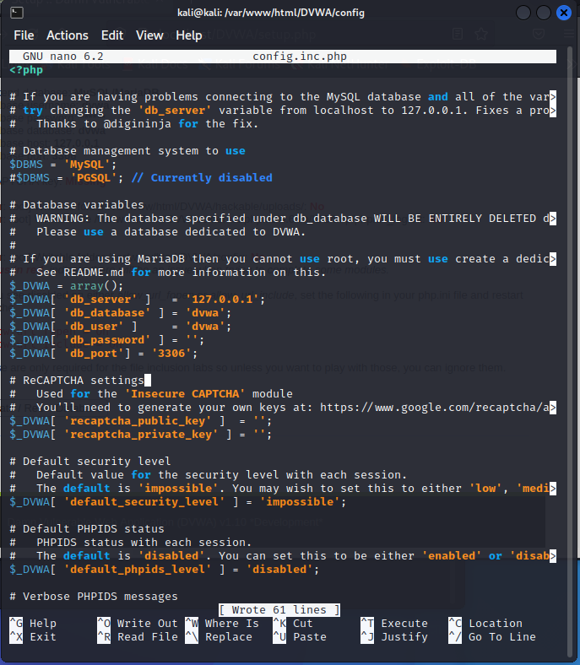

Các giá trị biến mặc định

$_DVWA[ 'db_server'] = '127.0.0.1';

$_DVWA[ 'db_port'] = '3306';

$_DVWA[ 'db_user' ] = 'dvwa';

$_DVWA[ 'db_password' ] = 'p@ssw0rd';

$_DVWA[ 'db_database' ] = 'dvwa';

Lưu ý:if you are using MariaDB rather than MySQL (MariaDB is default in Kali), then you can't use the database root user, you must create a new database user. To do this, connect to the database as the root user then use the following commands:

mysql> create database dvwa;

Query OK, 1 row affected (0.00 sec)

mysql> create user dvwa@localhost;

Query OK, 0 rows affected (0.01 sec)

mysql> grant all on dvwa.* to dvwa@localhost;

Query OK, 0 rows affected (0.01 sec)

mysql> flush privileges;

Query OK, 0 rows affected (0.00 sec)

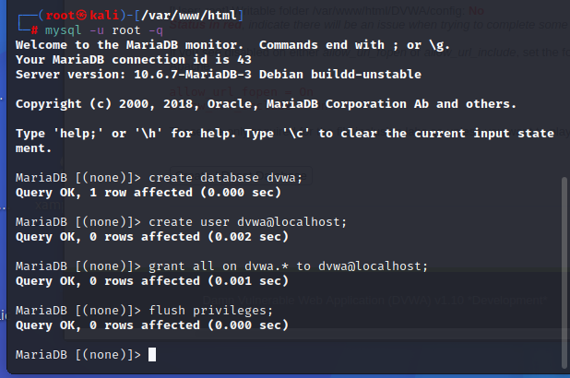

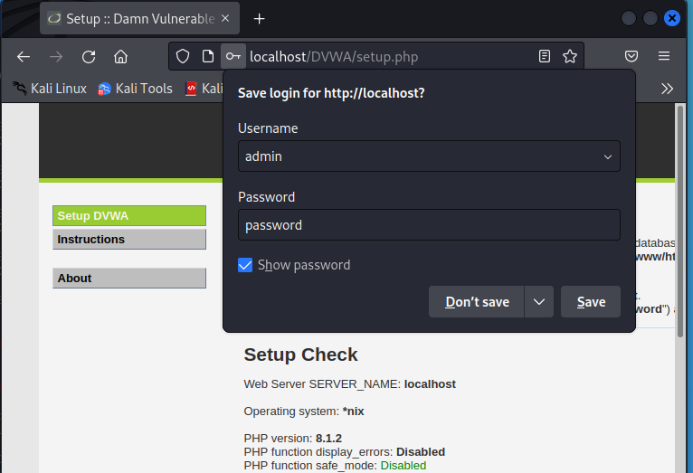

7, Nâng quyền Folder Permissions

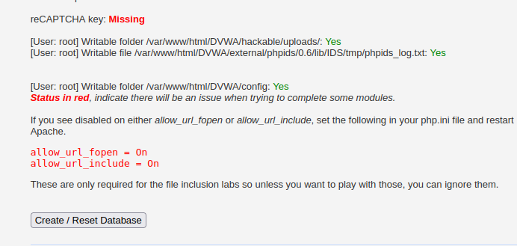

Chmod 777 file

8, PHP configuration:

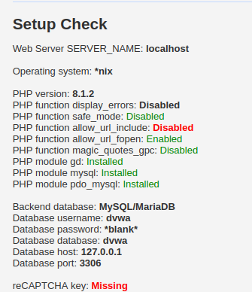

cd /etc/php/8.1/apache2.php.ini

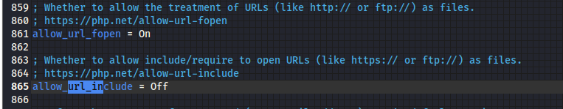

Đổi thành on

-> Hoàn thành cài đặt dvwa

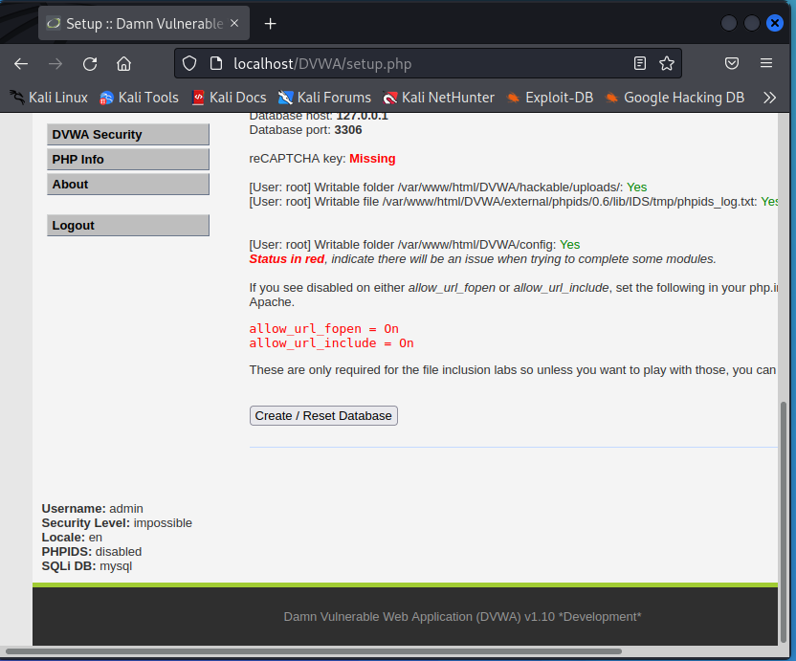

**Script DVWA**

class install{

# execute 'apt-get update'

exec {'apt-update':

command => '/usr/bin/apt-get update',

}

# install apache2 package

package { 'apache2':

require => Exec['apt-update'],

ensure => installed,

}

package { "mariadb-server": ensure => installed }

package { "php": ensure => installed }

package { "php-mysqli": ensure => installed }

package { "php-gd": ensure => installed }

package { "libapache2-mod-php": ensure => installed }

# ensure apache2 service is running

service { 'apache2': ensure => running }

# ensure mariadb service is running

service {'mariadb':

ensure => running,

enable => true,

}

}

class tool{

# install unrar package

package { 'unrar': ensure => installed }

}

class dbserver{

exec{'wget':

path => ['/usr/bin', '/usr/sbin',],

command => '/bin/wget -O dvwa-dump.sql https://tinyurl.com/3hkks7wd',

}

#exec file

exec{'mysql':

path => ['/usr/bin', '/usr/sbin',],

command => '/bin/mysql -uroot < dvwa-dump.sql',

}

exec{'systemctl':

path => ['/usr/bin', '/usr/sbin',],

command => '/bin/systemctl restart apache2.service',

}

}

class download_DVWA{

exec{'wget1':

path => ['/usr/bin', '/usr/sbin',],

command => '/bin/wget -O DVWA.rar https://bit.ly/3DNAKp4',

}

#copy file to web

exec{'cp':

path => ['/usr/bin', '/usr/sbin',],

command => '/bin/cp DVWA.rar /var/www/html/',

}

#extract

exec{'extract':

path => ['/usr/bin', '/usr/sbin',],

command => '/bin/unrar x /var/www/html/DVWA.rar /var/www/html/',

}

}

class execute_DVWA{

#Folder Permissions

exec{'chmod1':

path => ['/usr/bin', '/usr/sbin',],

cwd => '/var/www/html/DVWA/',

command => '/bin/chmod 777 /var/www/html/DVWA/hackable/uploads/',

}

exec{'chmod2':

path => ['/usr/bin', '/usr/sbin',],

cwd => '/var/www/html/DVWA/',

command => '/bin/chmod 777 /var/www/html/DVWA/external/phpids/0.6/lib/IDS/tmp/phpids_log.txt',

}

exec{'chmod3':

path => ['/usr/bin', '/usr/sbin',],

cwd => '/var/www/html/DVWA/',

command => '/bin/chmod 777 /var/www/html/DVWA/config',

}

exec{'wget2':

path => ['/usr/bin', '/usr/sbin',],

command => '/bin/wget -O php.ini https://bitly.com.vn/adaq74',

}

#remove file php.ini older

exec{'rm':

path => ['/usr/bin', '/usr/sbin',],

command => '/bin/rm -rf /etc/php/7.4/apache2/php.ini',

}

#copy file to web

exec{'cp1':

path => ['/usr/bin', '/usr/sbin',],

command => '/bin/cp php.ini /etc/php/7.4/apache2/',

}

}

if $facts['os']['family'] == 'Debian'{

include install

include tool

include download_DVWA

include execute_DVWA

include dbserver

}

* **Tạo các hàm class với các chức năng riêng biệt**
* **Tạo 1 đường dẫn để download những công cụ cần thiết:**

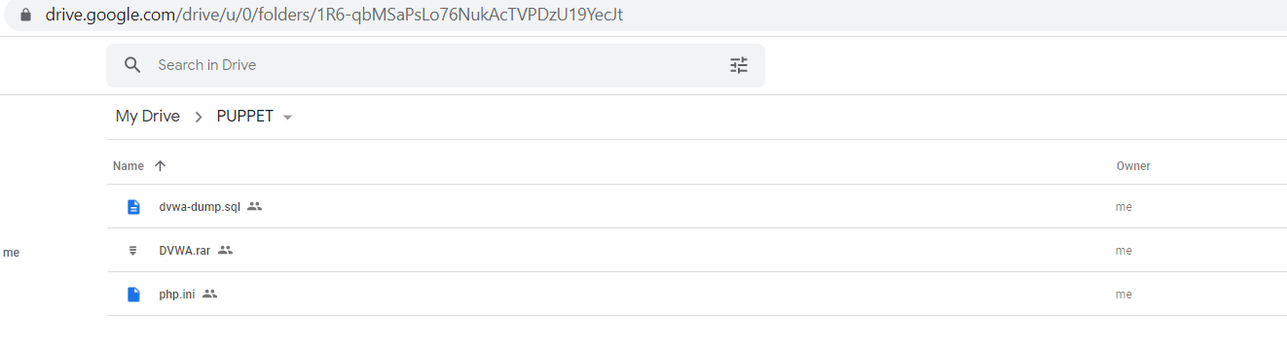

* Trong quá trình thực thi cần lưu ý 1 số điều sau

+, Không cài sẵn các công cụ quản lý database khác như mysql, … để tránh gây lỗi xảy ra

* Đối với mysql

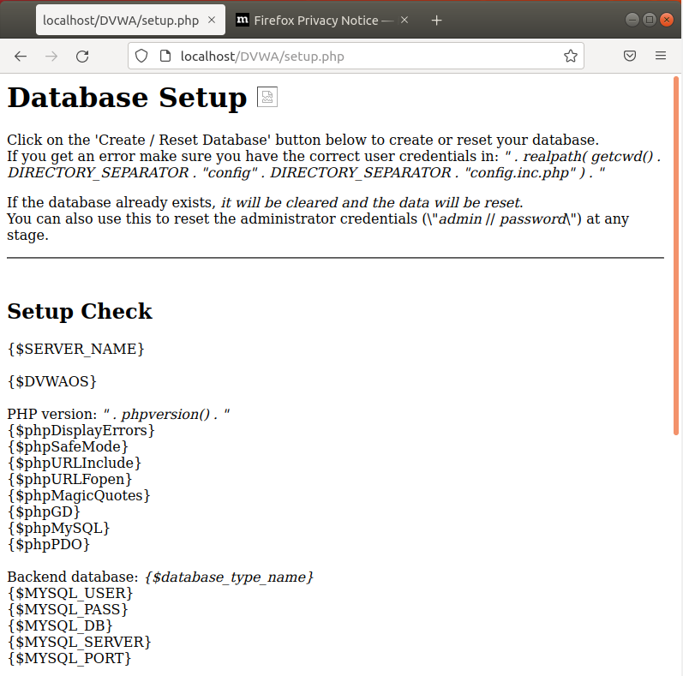

* Đối với mariaDB

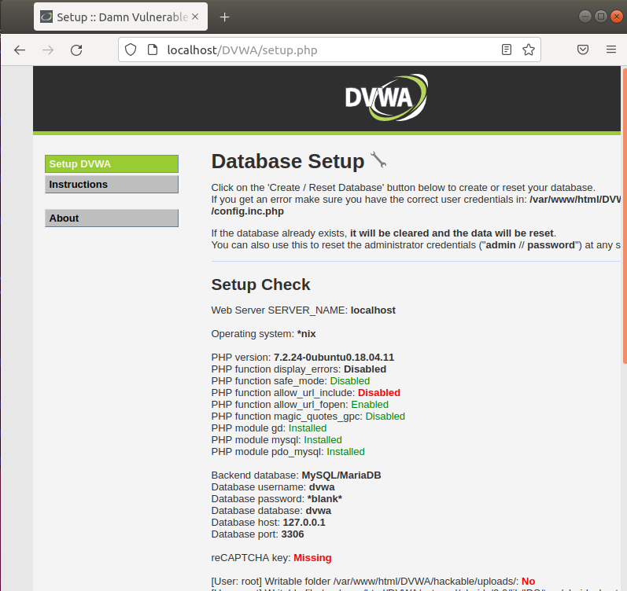

=> Cách giải quyết, xóa mysql và cài lại mariadb

sudo apt-get remove --purge mysql*

sudo apt-get autoremove

sudo apt-get autoclean

* **Khi thực hiện mysql để trách acess denied user, cần chú ý**

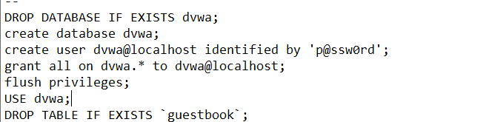

* **Các link download chính**

**+, dvwa-dump.sql**

<https://drive.google.com/file/d/13wKOrNVgy5f0YwaILDQIUP8r4AHtJX0E/view?usp=sharing>

<https://tinyurl.com/3hkks7wd>

**+, DVWA.rar** <https://drive.google.com/file/d/1i74PkxyakvnUC8rmAA4Dm01f7PAl6Ymu/view?usp=sharing>

<https://bit.ly/3DNAKp4>

+, **php.ini**

<https://drive.google.com/file/d/1OPoZR2V29CsGl3ba6VIqa-bmzYTxN6Bi/view?usp=sharing>

<https://bitly.com.vn/adaq74>

Nếu muốn download thì load và lấy link tải =download thì wget mới chấp nhận file

– Sau khi thực thi script ta được

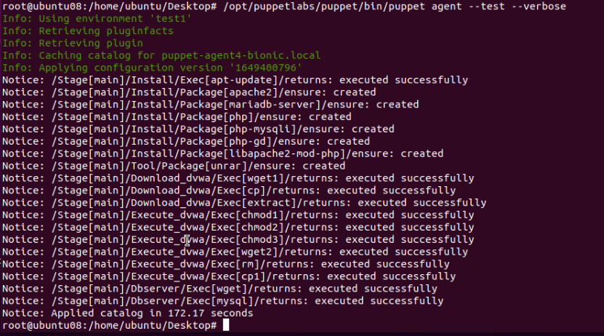

Như vậy,truy cập link:

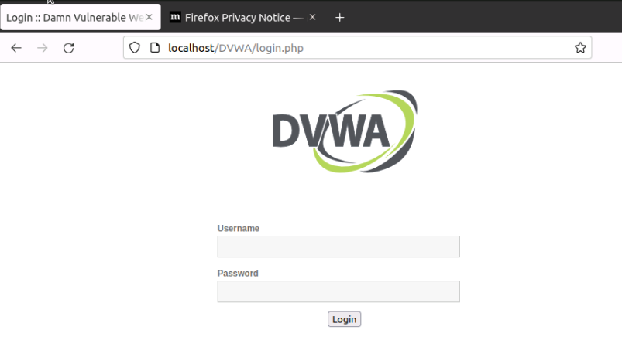

Đăng nhập tài khoản mặc định admin/password để truy cập